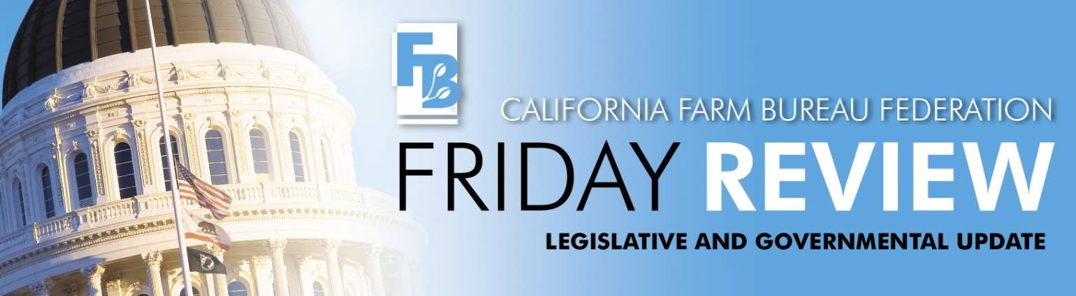
June 7, 2013
Last week was the deadline for getting bills out of their house of origin into the next house. No sooner were the session’s adjourned in both houses when work began in earnest in the Joint Legislative Conference Committee tying up numerous loose ends pertaining to the 2013-14 state budget. Three major items of concern to agriculture are being discussed that Farm Bureau is actively working on with a number of other agricultural and business groups. The actual budget language for any of the three items has not been released for public review, so we can only react to the brief information that is available.
First, the Assembly has proposed adding seven personnel to the State Water Resources Control Board to increase oversight and enforcement of the Irrigated Lands Regulatory Program and to address issues associated with high nitrate groundwater. They have proposed $969,000 in additional water user fees to fund these seven additional SWRCB staff. This increase would be in addition to proposed fee increase of 20.5% for the Waste Discharge Permit Fund for FY 2013-14. This fund, which contains 8 different programs, is now 100% fee supported. Many farmers pay into more than one of the eight programs. The seven new SWRCB positions proposed by the Assembly in the budget negotiations will increase fees on farmers for the irrigated lands program approximately 48.2% or from the current 56 cents/acre to 83 cents/acre.
Second, the Assembly proposed adding seven new personnel to the California Department of Food and Agriculture to increase the state’s regulation and understanding of groundwater nitrate contamination. Although the language provided does not provide details on how these positions would be utilized, these seven positions will require a $1.2 million increase, presumably on fertilizer. Currently, farmers within the Central Valley and the Central Coast regions pay for mandatory Regional Water Board regulatory program monitoring and reporting costs of $4.00-$13 per acre. Additionally, these farmers have significant costs related to the implementation of new beneficial management practices and infrastructure upgrades to comply with the surface and groundwater elements of the Irrigated Lands Regulatory Program.
These fourteen personnel at CDFA and the SWRCB proposed by the Assembly in the budget negotiations would cost the agricultural community an additional $2,188,000.
Third, the Assembly proposed increasing community protections from pesticide contamination and oversight of pesticide application as related to the Department of Pesticide Regulation. We understand this would be implemented by giving local governments the authority to regulate pesticides in ways that are inconsistent with the state’s science based approach. Pesticides are used by a multitude of various industries in many different settings− not only in agricultural and structural products but also in consumer products such as disinfectants. Disinfectants are regularly used in hospitals, restaurants, schools and homes to protect public health. Local control will result in a patchwork of regulations that will be difficult for the regulated community and regulators to follow, potentially putting human health and environmental safety at risk.
Farm Bureau and many agricultural and business groups are working hard to urge that all three of these Assembly proposals be rejected.
SB 43 (Lois Wolk-D, Vallejo) was approved by the Senate on May 30 to allow developers of renewable energy to sell electricity directly to utility customers. The program would be in addition to the renewable energy the utilities are mandated by state law to purchase. CFBF is opposed because of the likely impacts of the 500 MW program to farmland and to ratepayers who do not participate in the program. SB 43 allows for projects up to 20 MW in size to be built out under the program. Although impacts to prime farmland were originally called out in the measure, albeit with little strength, that language was removed and replaced with intent language in favor of “preserving a thriving natural environment.” A number of amendments were taken a couple of days before the floor vote focused on the cost elements of the program that had been included. Much of the specific language was deleted and replaced with direction for the Public Utilities Commission to assess appropriate costs and credits for the program as well as not to allow a net cost shift to nonparticipants. The ability to enforce the limits on cost shifting to nonparticipants in the program may be constrained by other requirements in the bill. SB 43 was approved 27-9.
The State Water Resources Control Board held a joint Stakeholder and Regulatory meeting this week for the draft Biological Objectives Policy. In early May the State Water Board had released draft documents covering three technical areas that they say serve as the foundation for the draft Biological Objectives Policy. The three draft documents cover 1) a description of the State’s perennial stream reference conditions, 2) a description of the new California Stream Condition Index for biological objectives that optimizes statewide consistency with local flexibility and 3) a description of the stressor identification process developed by U.S. EPA and important considerations for its use with biological objectives. The documents can be accessed at: http://www.waterboards.ca.gov/plans_policies/biological_objective.shtml and scroll down the page to Resources & References. The full day meeting began with the focus and discussion on technical issues and after lunch shifted to policy and implementation considerations. Farm Bureau participated in the meeting and will continue to stay engaged and comment on the proposed policy.
Bills of interest to agricultural employers are moving to hearings in policy committees in the second house:
AB 1165, by Assembly Member Nancy Skinner (D-East Bay), will he heard at the Senate Labor and Industrial Relations Committee on June 29. AB 1165 would change current law so that abatement of a serious, willful, or repeated violation of a Cal/OSHA standard, or a failure to abate a prior violation cannot be delayed by an appeal of the citation by the employer. Farm Bureau and other employer groups oppose AB 1165.

SB 25, by Senate President Pro-Tem Darrell Steinberg (D-Sacramento), expands mandatory mediation from labor agreement negotiations where the parties cannot reach agreement to all future negotiations. It would impose unionization on unsuspecting agricultural employees years or even decades after an initial vote certification and could create the situation that the newly unionized employees never voted for the union. SB 25 will be heard at the Assembly Labor & Employment Committee on June 12. Agriculture is opposed.

SB 168, by Senator Monning (D-Carmel), seeks to end the practice of subsequent “sham” formation of Farm Labor Contractor businesses in order to deprive workers of their rightful wages. Unfortunately it is so broadly written that it may impose burdens on any subsequent FLC who had nothing to do with the prior offenses. By specifying that the liability “travels with” the business and even the employees of the guilty former FLC, that former FLC’s equipment may become unusable and his employees may become unemployable. Farm Bureau and other agricultural groups have sought clarification to ensure bad-actor FLC’s cannot “flip” FLC licenses. SB 168 will be heard in the Assembly Labor Committee on June 26. Farm Bureau and other agricultural groups are opposing, but seeking amendments

The Assembly Labor and Employment Committee will hear SB 435 by Alex Padilla (D-Pacoima), most likely after the summer break. This bill requires employers to pay employees at their piece-rate earning rate for on the clock breaks; including those taken pursuant to law in the morning and the afternoon as well as for heat illness prevention breaks. The industry has expressed serious concerns about the recordkeeping aspects of complying with this mandate for heat illness breaks, which are unscheduled, and unplanned. Failure by an employer to record the beginning, end and duration of such breaks could result in substantial penalties. Farm Bureau and most agricultural groups oppose SB 435.

