Mark Stopher
California Department of Fish and Game
601 Locust Street
Redding, CA 96001 dfgsuctiondredge@dfg.ca.gov
03 May 2011

RE: Comments regarding SEIR and Proposed Regulations for suction dredge mining in California in Favor of Maintaining Current 1994

Dear Sir:

Thank you for allowing us the opportunity to comment on the California Department of Fish & Game’s (DFG) Suction Dredge Permitting Program Subsequent Environmental Impact Report (SEIR) and Proposed Regulations.

I, Claudia Wise, and Joseph Greene are retired U.S. EPA Scientists and invited members of the CDFG SEIR Public Advisory Committee. During the PAC meetings we presented two science based PowerPoint presentations to the committee “Selenium Antagonism to Mercury, Does Methylmercury Cause Significant Harm to Fish or Human Health?” and “Turbidity and the Effect of Scale”.

Claudia Wise is a retired Physical Scientist previously employed at the U. S. Environmental Protection Agency, Corvallis Environmental Research Laboratory, Corvallis, OR. I have 29 years experience in chemical and biological instrumentation methods. I spent 8 years with the Western Fish Toxicology Station coauthoring journal articles dealing with bioaccumulation in Invertebrates and Fish exposed to chemical toxiciants. I have contributed to many projects and coauthored numerous journal articles for the Watershed Ecology, Terrestrial, Ecotoxicology and Freshwater Branches where I researched toxicity in soil and the effects of toxicants on plant growth. At the time of my retirement, I was with the Watershed Ecology Stable Isotope Research Facility. I am a recipient of the United States Environmental Protection Agency Bronze Medal for Commendable Service.

Joseph Greene has over 30 years of national and international professional experience including consulting, research, and teaching for industry and government regulatory agencies. Activities included project management, contract administration, experimental design, preparation of research reports and technical documents, laboratory supervision, statistical analysis of data, computer simulation, development and application of biological methods, and performance of algal growth potential and aquatic and terrestrial toxicity tests.

Consulting experience included assessment of nutrient pollution in freshwater canals and rivers, assessment of heavy metals toxicity from mining activities and paint stripping, investigation of toxicity and bioaccumulation in soils at military facilities, evaluation of water soluble and soil toxicants at Superfund sites, and assessment of algal toxicity from textile dyes.

Research activities included establishment of an ecotoxicology laboratory, development of a biological-chemical-physical protocol for measuring potential toxicity of construction materials, development of internationally standardized test methods (aquatic algae, aquatic macroinvertebrate, terrestrial plant and terrestrial invertebrate), chairman of testing committees for ASTM and Standard Methods, platform chairman of several international symposiums, workshops, and congresses, and invited speaker to numerous national and international professional scientific meetings.

Teaching experience included a number of short courses and workshops on performance of algal growth potential and interpretation of results across the nation, a workshop on environmental analysis techniques in Europe, a workshop on complex problems with point and non-point sources of water contamination for the US Department of the Interior, and an environmental engineering graduate seminar on toxicity testing for environmental engineering applications.

Government agencies experience included project management, experimental design, hands-on research, data analysis, and report writing.

Since retirement both of us have participated, as a team, to defend the rights of small scale suction dredging using science to establish the “Less Than Significant effects of the practice. Joseph Greene primarily investigated biological effects and Claudia Wise investigated water quality effects. Post USEPA experience includes a Preliminary Klamath River Water Quality Survey examining surface water temperatures.

According to the DFG Suction Dredge Permitting Program SEIR NOA (SCH #2005-09-2070) regarding the Notice of Availability of a DSEIR for Suction Dredge Permitting Program (SCH#2009112005), “The Draft SEIR evaluates the potential environmental impacts of the proposed program and four alternatives:

No Program alternative….;

1994 Regulations alternative…;

Water Quality alternative (which would include additional program restrictions for water bodies listed as impaired pursuant to the Clean Water Act (CWA) section 303(d) for sediment and mercury); and,

Reduced intensity alternative (which would include greater restrictions on permit issuance and methods of operation to reduce the intensity of environmental effects).

It should be noted that the directive of the court was to identify any suction dredge issues that were detrimental to fish yet the CADFG paid the contractors to spend an inordinate amount of time extrapolating possible situations that were never a part of the court order. If any of these additional findings were to be enforced they could keep small scale suction dredgers from plying their trade and earning income.

During the court proceedings, which ordered the completion of this SEIR, the attorneys for the CDFG told the court that they had scientific information that small-scale suction dredging might be harmful to fish. It is fact that during discovery by the agents of the miners the CDFG attorneys refused to provide the scientific evidence they claimed was in their possession. Therefore, under court order, CDFG is spending a large amount of tax dollars to find scientific data that dredging harmed fish….data the State claimed to have in its possession prior to the court ordering the SEIR study be performed. And yet, the contents of the SEIR illustrate that the effects of suction dredging on fish, in every instance, is “Less than Significant”.

The SEIR results clearly illustrate that the State never possessed any additional scientific evidence they claimed would prove small-scale suction dredging was detrimental, in any way, to fish or wildlife beyond the data already analyzed in the 1994 EIR. The public’s money could certainly have been used more productively, in a cash strapped State, than having it used to try and destroy an economic sector of a State already in financial trouble. The basis for the entire SEIR process was founded upon a lie presented by the State’s attorneys.

The conclusions for the effects of suction dredging on fish are as follows and are the same as those found in the 1994 EIR and support the positions that the miners have always argued:

- Impact BIO‐FISH‐1: Direct Effects on Spawning Fish and their Habitat (Less than Significant)
- Impact BIO‐FISH‐2: Direct Entrainment, Displacement or Burial of Eggs, Larvae and Mollusks (Less than Significant)
- Impact BIO‐FISH‐3: Effects on Early Life Stage Development (Less than Significant)
- Impact BIO‐FISH‐4: Direct Entrainment of Juvenile or Adult Fish in a Suction Dredge (Less than Significant)
- Impact BIO‐FISH‐5: Behavioral Effects on Juvenile or Adults (Less than Significant)
- Impact BIO‐FISH‐6: Effects on Movement/Migration (Less than Significant)
- Impact BIO‐FISH‐7: Effects on the Benthic Community/Prey Base (Less than Significant)
- Impact BIO‐FISH‐8: Creation and Alteration of Pools and other Thermal Refugia (Less than Significant)
It is generally accepted that most of the pools made by small scale suction dredges last only until the following winter high water flows arrive. In the meantime they serve the fish as resting areas and safe locations from predation. The pools may or may not intersect cold ground water or hyporheic subsurface flows. This fact does not negate or makes the pools less beneficial to the survival of salmonids. The pools still serve as resting and protective locations between thermal refugia, that are generally located at the mouths of confluent streams that could be located some miles away.

We disagree with the Less Than Significant conclusion and would recommend that it be changed from Less than Significant to Beneficial.

Dredge holes 3 feet or deeper are considered adequate refugia for fish. Excavating pools could substantially increase their depth and increase cool groundwater inflow. This could reduce pool temperature (Harvey and Lisle 1998). If pools were excavated to a depth greater than three feet, salmonid pool habitat could be improved. In addition, if excavated pools reduce pool temperatures, they could provide important coldwater habitats for salmonids living in streams with elevated temperatures (SNF, 2001).

- Impact BIO‐FISH‐9: Destabilization/Removal of Instream Habitat Elements (e.g., Coarse Woody Debris, Boulders, Riffles) (Less than Significant);
- Impact BIO‐FISH‐10: Destabilization of the Stream bank (Less than Significant);
- Impact BIO‐FISH‐11: Effects on Habitat and Flow Rates Through Dewatering, Damming or Diversions (Less than Signigicant).

We understand that the SEIR is using a 4-inch intake nozzle size limit to establish these “Less than Significant” conclusions. However, the published science does not support their projected nozzle size limitation. The small-scale suction dredge study in Fortymile River, Alaska was performed using 8- and 10-inch dredges. Prussian, et. al. (1999) concluded that, “suction dredge mining clearly reduces macroinvertebrate densities, diversity, BOM, and periphyton immediately below dredge activity regardless of the background conditions, though these effects are local and short lived.”

The test results for the Chatanika River and Resurrection Creek, Alaska studies reflected the seasonal impacts from the use of small-scale suction dredges that had nozzle sizes ranging from 2- to 6-inches. The Chatanika River and Resurrection Creek sites, “represent the best examples of concentrated mining activity we could find and should be considered "worst-case" scenarios because both streams receive considerable mining activity and have relatively well-defined downstream boundaries. Together with the results of other studies, we suggest that the impacts by small-scale dredging activity are primarily contained within mined areas and persist for about one month after the mining season.” This is clearly the definition of “Less than Significant”.

Since harm to fish is no longer the issue, according to the findings in the SEIR, we will address the issues that were identified as “significant and unavoidable”. They are:

Impact WQ‐4. Effects of Mercury Resuspension and Discharge from Suction Dredging (Significant and Unavoidable);

Impact WQ‐5. Effects of Resuspension and Discharge of Other Trace Metals from Suction Dredging (Significant and Unavoidable);

Impact CUM‐8. Cumulative Impacts of Resuspension and Discharge of Other Trace Metals from Suction Dredging (Less than Significant);

If these subject areas were important enough to investigate, and expend public funds, they should be analyzed in the proper light that peer-reviewed scientific analytical standards demands. It is stated in the notice of availability that “The analysis found that significant environmental effects could occur as a result of the proposed program (and several of the program alternatives), specifically in the areas of water quality, and toxicology, noise, and cultural resources. Although CDFG does not have the jurisdictional authority to mitigate impacts to these resources, they were, nevertheless, identified as significant and unavoidable.”

In Chapter 4.2, WATER QUALITY AND TOXICOLOGY of the DSEIR the first issue of significant and unavoidable impact is “Impact WQ‐4. Effects of Mercury Resuspension and Discharge from Suction Dredging (Significant and Unavoidable)”.

You have provided no direct dredging evidence to support this! You state, “Few dredge studies are available regarding how small scale suction dredging specifically affects mercury. However two important, high quality studies present results indicating less than significant effects.

A cumulative study using an 8 and 10-inch dredge (actually operating in a flowing river) commissioned by the USEPA (1999) produced values of dissolved mercury that were actually greater upstream of the dredge, suggesting that any effect of the dredge was likely within the range of natural variation. The operator reported observing deposits of liquid mercury within the sediments he was working. This is the most relevant piece of published scientific evidence, addressing dredging at intensity beyond that typically experienced in California, with real world interceptions of occasional mercury deposits. The draft fails entirely to explain how any other information undermines the conclusions of this study.

Humphrey (2005) demonstrated that at least 98% of the mercury was retained in the sluice box of the dredge. The fact remains that most suction dredgers do not find mercury hotspot’s. Most dredgers report seeing only occasional drops of mercury or amalgamated gold…if any. The highly infrequent nature of mercury interceptions confirms the lack of significance.

Humphreys (2005) and Marvin-DiPasquale (2009) made an attempt to quantify effects of small scale suction dredging on mercury. Their work has added bits of information to the database of known mercury hotspots. However, their work added very little information to the known effects that suction dredges may have on mercury in the “normal” environment. Later attempts to quantify the effects of dredging on mercury (Fleck 2011) were unsuccessful even when:

- They skewed the results by intentionally establishing a study directed at the worst case, most contaminated, location in the State of California; and,
- Attempted, using data from a non-dredge study, to draw statewide conclusions “calculating” the movement of greater quantities of mercury from one 8-inch dredge than is moved in an entire year by natural flood conditions.

According to Fleck (2011), “It is important to note that the results presented in this publication were not developed using a full-scale dredge operation.” As a matter of fact, other than for the 3 inch dredge portion of the study, no dredge was used!!! The procedure is categorically not a scientifically acceptable or environmentally realistic calculation of results to be scaled-up quantitatively to reflect what would occur from the outflow of a “real” dredging operation. Fleck further hedged, “The results of the test should be evaluated as valuable information regarding the proof of concept [of site remediation] rather than a quantitative evaluation of the effects of suction dredging on water and sediment in the South Yuba River.” (Fleck 2011).

The first significant failure of this project was not returning the funding to the California State agencies when it was determined USGS would not be allow the use of small-scale suction dredges in the river to perform the suction dredge study. Following that decision the main scope of the project was manipulated to provide pre-conceived answers to the questions the State agencies were seeking. These actions have the appearance that the only goal of forcing these data was to provide grounds for the State agencies to control the waters of California by closing areas or placing strict requirements in areas used by suction gold dredgers. All of this would be based on non-peer reviewed grey literature science like the Humphrey (2005) and Fleck (2011) studies. A legitimate scientifically designed study would have a hypothesis that would have been formulated to find the best information based on data, from actual small-scale suction dredge operations. Fleck (2011), makes it clear when he states, “the scope of the study was modified to accommodate concerns by the State Water Resources Control Board and California Regional Water Quality Control Board, Central Valley Region”. These concerns could have been laid to rest simply by moving the test site to a more natural segment of the river system rather than staying in the chosen location of a site known to contain the greatest concentration of mercury in California

Fleck (2011, page 5) stated, “The revised project scope replaced the planned full-scale suction-dredge test with study elements 2 and 3, which focused on a more complete assessment of sediment composition and Hg contamination and speciation as a function of grain size, as well as current and historical sources of contamination at the SYR-HC confluence site. The information generated in this study could have been valuable in determining the potential for Hg transport due to dredge activities through simulation (emphases added) calculations.”

Fleck (2011) further described his concern for human health stating that, “Ultimately, the importance of the results of this study relate to whether the Hg in the sediment has a negative effect. Potential for a negative effect is closely related to the transport of sediment into the water column where it may become a threat to local users or be transported downstream.” Presenting these concerns does not make them true especially without adding a study element regarding the bioavailability of released mercury, in the presence of naturally occurring selenium, to cause harm. Therefore, we remain without an answer to the question of what negative effects may be generated from any of the sources of mercury contamination on exposed organisms. Once one has the knowledge that mercury and selenium interact antagonistically it is scientifically unacceptable to comment only on the mercury data without consideration of the selenium data that can demonstrate the total elimination of mercury toxicity

The Fleck (2011) study does further disservice to legitimate science by presenting information calculated on data not collected during the study. He stated, “Unfortunately, the rate at which sediment was moved during the dredge test was not quantified during this study, therefore this evaluation is based on qualitative observation only.” Flow rates from a dredge are site specific and cannot be substituted for industry flow rates that are used to sell dredges. Knowing this Fleck (2011} concludes “These estimates are, like the previous analysis, dependent on numerous assumptions and estimates and thus possess a high degree of uncertainty.”

On the very same project, when a three inch dredge was used, the researchers found no significant level of mercury flowing out of the sluice box. Results of the three inch dredge study are listed below:

- Concentrations of particulate total mercury increased in a similar manner as total suspended solids, with concentrations during the suction dredging two times the pre-dredging concentration and three to four times the concentration of the samples collected the following day.
- Concentrations of filtered total mercury in the South Yuba River during the dredge test were similar to those in the field blanks (i.e., field control samples).
- Dredging appeared to have no major effect on particulate methylmercury concentrations in the South Yuba River during the dredge operations.

Results from this three inch dredge study are the closest data presented in this report that reflect the effects of an honest dredge study. However, these results are of insufficient quality or sample quantity to allow for a conclusion that particulate total mercury will float indefinitely down a waterway as Fleck’s (2011) conclusion suggests. In fact, there are peer-reviewed journal articles that provide the necessary data to show this is not the case.

USEPA commissioned a study on the impact of suction dredging on water quality, benthic habitat, and biota in the Fortymile River, Resurrection Creek, and Chatanika River, Alaska (Royer, 1999). The results showed that although total copper increased approximately 5-fold and zinc approximately 9-fold at the transect immediately downstream of the dredge, relative to the concentrations measured upstream of the dredge, both metals concentrations declined to near upstream values by 80 m downstream of the dredge.

It was suggested the pattern observed for total copper and zinc concentration is similar to that for turbidity and total filterable solids. The metals were in particulate form, or associated with other sediment particles. The results yielded a similar effect to what Fleck (2011) found regarding particulate total mercury in the South Yuba Humbug creek confluence. However, the Alaskan data provided a totally different outcome than Fleck leads us to believe resulted from his study that did not use a suction dredge to develop the data.

The Fortymile River suction dredge study, using 8 inch and 10 inch suction dredges, measured the distance the metals associated with the sediment particles moved in the water column before settling back to the bottom of the river. The sediment particles did not float indefinitely as Fleck leads us to believe. Zinc at 7.10 g/cm³ and copper at 8.92 g/cm³ have significantly lower densities than mercury at 13.55 g/cm³. Zinc and copper average slightly more than half the weight of mercury. Yet those elements only floated 80 meters. The only reasonable inference, absent real data to the contrary, is that Hg, which has almost twice the weight of copper or zinc, would, as gravity dictates; sink to the river bottom in a shorter or, at least, no greater distance downstream.

What value is there to the public interest when a federal agency, such as USGS, forms the hypothesis of a worst case scenario regarding small-scale suction dredging based on a study performed without using a suction dredge? A project where no suction dredge measurements were taken will never be a substitute for honest factual data. No one should be allowed to force results from an ill conceived project on the citizens of California as scientific truth.

In the California Department of Fish and Game, February 28, 2011 proposed suction dredge regulations the definition of a suction dredge is as follows:

Suction dredging. For purposes of Section 228 and 228.5, the use of vacuum or suction dredge equipment (i.e. suction dredging) is defined as the use of a motorized suction system to vacuum material from the bottom of a river, stream or lake and to return all or some portion of that material to the same river, stream or lake for the extraction of minerals. A person is suction dredging as defined when all of the following components are operating together:

A) A vacuum hose operating through the venturi effect which vacuums sediment in the river, stream or lake; and,
B) A motorized pump; and,
C) A sluice box.

Below are photographs of the Fleck (2011) mercury hotspot “suction dredge” and the one hole from which the sample was collected. This single tub of water is what is being used in the SEIR to define mercury contamination from all suction dredges working the waters of California.

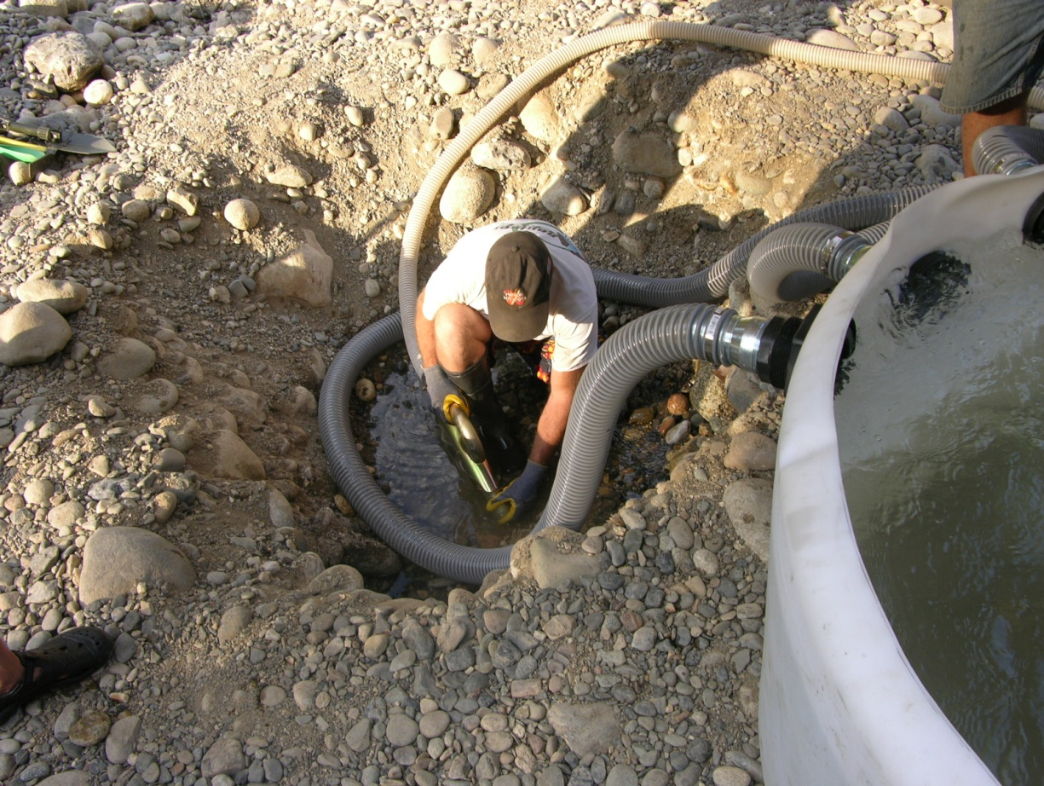

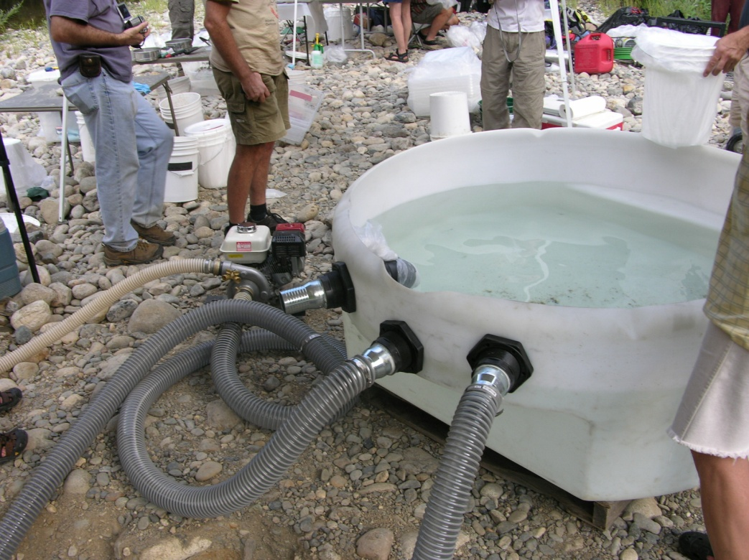

And for those unfamiliar with suction dredging the following photograph will reveal that the dredge floats on the water and is intended to vacuum the overburden from the river or creek bottom. The vacuumed material, (i.e., clay, sand, rocks,) pass through a sluice box that captures the heavy materials (i.e., gold, lead, platinum, mercury) while returning the other materials back to the receiving water.

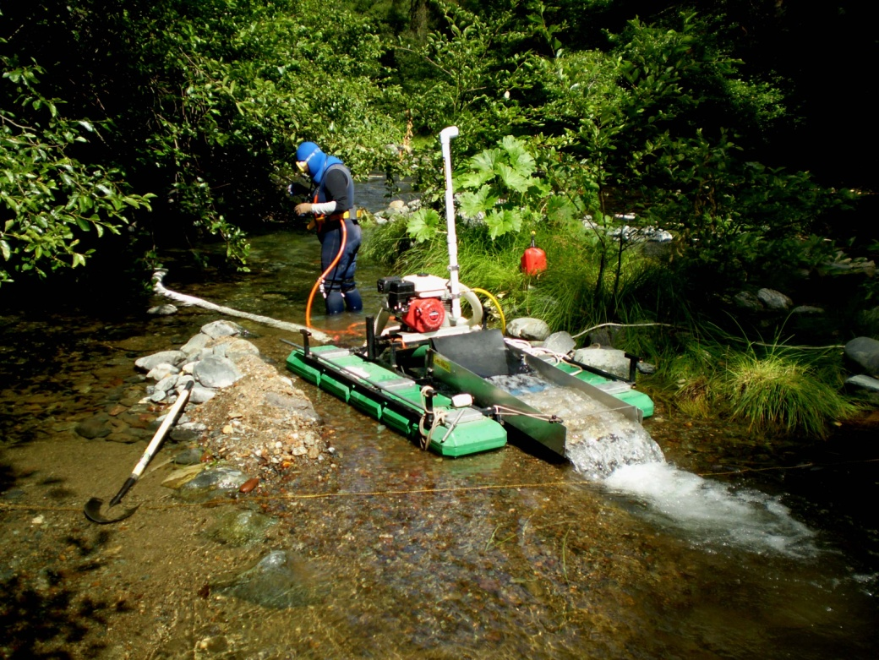

It states in the SEIR that “The effects of Hg contamination from historic mining activities in California are being extensively studied and there is substantial literature regarding Hg fate and transport. However, there are very few published studies specifically addressing the effects of suction dredging on Hg fate and transport processes. Since the time the literature review (Appendix D) was prepared, USGS scientists and Hg experts provided CDFG with preliminary results of their recent research in the Yuba River “which is specifically focused on assessing the potential discharge of elemental Hg and Hg enriched suspended sediment from suction dredging activities. This new information and data from USGS was used in formulating the approach to this assessment of the Program.” The statement is followed by the following diagram.

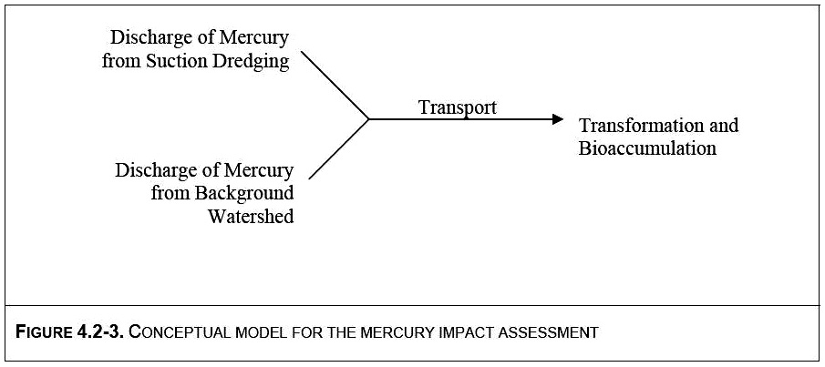

The statement highlighted in red is factually false and is grounds for dismissing any results from this model. We have no criticism of the modeling approach itself as that is outside of our area of expertise. However, anyone that has worked in science and with modelers understands that the quality of the results is predicated upon the quality and accuracy of the input. There is a term for a model that has used bad or questionable data. It is “garbage in, garbage out”. This comment does not reflect on the individual providing the model but, only on the quality of information he is provided. If you were to look at the diagram of the conceptual model it is very clear the element “Discharge of mercury from suction dredging”, as defined by the above description from the USGS, is entirely dishonest. Furthermore, we must point out that there is not a control sample from the test site itself. Our understanding is that just one hole was flooded and sucked out using a closed circuit device repeatedly recirculating the water (not a dredge) and historical chemistry for the Yuba River was used as the control data. Not scientifically acceptable!

To prove our point we have only to go back to the statement, “USGS scientists and Hg experts provided CDFG with preliminary results of their recent research in the Yuba River which is specifically focused on assessing the potential discharge of elemental Hg and Hg enriched suspended sediment from suction dredging activities.” This statement is false. The California State Water Board denied the researchers the right to use an eight-inch suction dredge in the river as the study had planned to do. Therefore, Dave McCracken, the mining consultant, was asked to determine where he believed might be the most contaminated sites for sampling. He did so. A hole was hand dug out on a gravel bar down to the water table. A closed circuit system was then used to suck the fluid and streambed material from the hole into a large container. The same water was circulated from the hole, into the container and back into the hole, over and over again for about an hour. (A second hole was also hand dug from bedrock outside of the active river (having been exposed to oxygen for potentially many years) just downstream from the most contaminated site.

It was these holes and test procedures that resulted in the measured concentration of the mercury being called dredge discharge. From this description it is clear a real suction dredge was not used to provide the results in the study and the materials did not represent the typical river overburden that had been undergoing natural cleaning from years of flushing winter floods. In fact it is stated that, “discharge of Hg from suction dredging was based primarily on field characterization of Hg contaminated sediments (Fleck et al., 2011). Background watershed mercury loading estimates were utilized to compare to suction dredge discharge estimates (Alpers, et al., in prep). There you have it in their words. Study results were based on contaminated sediments outside the river, or from highly-re-circulated water not representative of ordinary dredging in the river and “background watershed mercury loading estimates were utilized” for the control, rather than precise comparative measures in this area known to have atypically high mercury contamination..

Furthermore, the entire discussion in the draft is written as mercury were a highly toxic, irreversible toxin that everyone should be deathly afraid of. This view is totally biased and slanted. It was bad enough to create a model based only on possibility of worst case factors influencing bioaccumulation, but worse still to not incorporate bioavailability considerations of Hg toxicity into the models assessment management evaluation. We do not see any discussion to the vast collection of published peer reviewed articles that support selenium’s antagonism to mercury and the resultant detoxification. This data should also be included in any discussion or model which is attempting to fairly represent any toxic effects to fish, wildlife, aquatic organisms and the environment in general

Examiner Columnist Ron Arnold wrote “Where does a regulatory agency run by political appointees find scientists willing to claim their subjective opinion is science? The FWS gets most of its science from U.S. Geological Survey biologists working in a closed loop: FWS gets science from USGS, USGS gets funded by FWS - which assures predetermined outcomes and no dissent. Interesting money trail, so where's Congress and the media?” We believe the information reflected in the Fleck, et al (2011) report should be viewed with this same skepticism. The dredge output conclusions calculated by re-circulating water through a hand dug hole, in the most highly mercury contaminated area known to the State of California, is the poorest excuse for science we have observed in our combined 60+ years of scientific research.

Intentionally seeking out and targeting site samples from areas containing known extreme levels of mercury contamination, rather than applying a scientific approach of random sampling, and using these data to draw conclusions that affect a whole State’s suction dredge industry is unacceptable. Even worse, the study observations were extrapolated to represent a real stream environment where, it is claimed, mercury would float indefinitely. While panning gold concentrates miners frequently see gold floating on the water until the surface tension is broken. But, overburden and oxygenated water flowing off the end of a sluice box submerges and mixes below the water surface. This turbulent action breaks the surface tension and the dense materials settle out in a short distance.

January 2010, EPA reported that “since suction dredge mining creates turbidity in the stream it is likely this action increases oxygenation of the waters and therefore, methylation of inorganic mercury would be less likely to occur in these habitats.” No quantitative evidence is presented concerning the degree of oxygenation, or whether it has any appreciable effect on general, downstream levels relevant to methylation processes. Determinations of significance require more than theorizing as to possible effects.

As one would expect the results of the USGS study (Fleck 2011) using the 3-inch dredge showed only a slight increase in particulate total mercury present in the water column immediately downstream of the suction dredge. Data indicating that an increase of particulate total mercury does not equate to an increased concentration or change in speciation to the more toxic form methylmercury.

It is important in dealing with science to occasionally step back and ask yourself ‘So what?’ It’s necessary as a scientist to not try to push the data and your resulting conclusion into a pre-conceived notion of what your initial theory was. The push to smear suction dredging with the presented information raises the question of whether we are dealing with scientists or activists working for the USGS. Let me quickly show you what a dredge study should look like.

In the following illustration, from the Fortymile River study in Alaska, you can see the dredge location in the river. There are two control sampling sites upstream of the dredge and several transects with multiple sites crossing the entire river. That is a true example of scientists performing high quality, subject specific research.

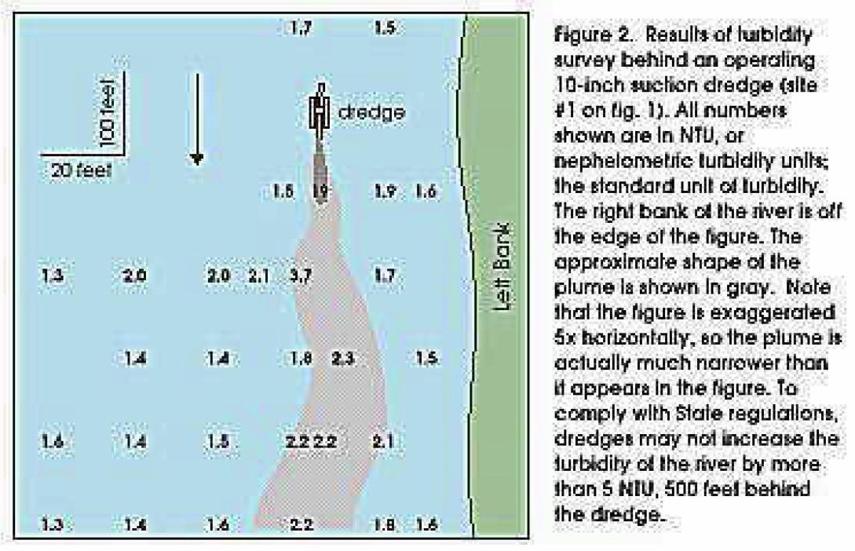

In the presentation to the CDFG PAC Claudia shared numerous peer-reviewed journal articles that prove selenium’s chemical antagonism to mercury, and other mercury species such as methylmercury, cause no significant harm to fish or human health. These published peer reviewed articles leave no doubt that toxicity from mercury contamination in historic mining basins is (Less than Significant).

There is no doubt that methylmercury may cause harm under the right circumstances. An example of this occurred in Minimata, Japan where inhabitants were exposed to 27 tons of mercury waste dumped in the bay but, with no corresponding shift in selenium levels. However, there has been a large body of (peer reviewed) evidence published that demonstrates that supplemental dietary selenium moderates or counteracts mercury toxicity. Mercury exposures that might otherwise produce toxic effects are counteracted by selenium, particularly when the Se:Hg molar ratios approach or exceed 1.” Selenium has a high affinity to bind with mercury thereby blocking it from binding to other substances, such as brain tissue. The bond formed is irreversible. “All higher animal life forms require selenium-dependent enzymes to protect their brains against oxidative damage (Peterson 2009)”. As early as 1967 Parizeik found that high exposures Se and Hg can each be individually toxic, but evidence supports the observations that co-occurring Se and Hg antagonistically reduce each other’s toxic effects.

In 1978, scientists from Sweden were reporting that “mercury is accompanied by selenium in all investigated species of mammals, birds, and fish,” adding that it “seems likely that selenium will exert its protective action against mercury toxicity in the marine environment” (Beijer 1978). Building onto the list of species known to be protected by selenium’s bond with mercury and the toxic effects of methylmercury, a group of Greenland scientists in 2000, published the results of mercury and selenium tests performed on the muscles and organs of healthy fish, shellfish, birds, seals, whales, and polar bears. They found that, “selenium was present in a substantial surplus compared to mercury in all animal groups and tissues” (Dietz 2000)

Not only ocean species but freshwater species are found to also be protected. Researchers at Laurentian University in Ontario, Canada reported that selenium deposits, from metal smelters into lake water, greatly decreased the absorption of mercury by microorganisms, insects, and small fish. Suggesting a strong antagonistic effect of selenium on mercury assimilation (Yu-Wei 2001). Peterson’s group (2009) collected 468 fish representing 40 species from 130 sites across 12 western states. Samples were analyzed for whole body selenium and mercury concentrations. The fish samples were evaluated relative to a wildlife protective mercury threshold of 0.1 ug Hg/g wet weight, and the current tissue based methylmercury water quality criteria for the protection of humans of 0.3 ug Hg/g wet weight and presumed protective against mercury toxicity where the Se:Hg molar ratios are greater than 1. The study included data from samples collected in California which, in all cases, contained proportions of mercury to selenium that were adequate to protect fish, wildlife and human health. Results showed 97.5% of the freshwater fish in the survey had sufficient selenium to protect them and their consumers against mercury toxicity. The California results were 100% protective.

Peterson’s (2009) research supports Ralston’s (2005) findings stating that “Mercury toxicity only occurs in populations exposed to foods containing disproportionate quantities of mercury relative to selenium.” Also supporting this finding inadvertently, the California Office of Environmental Health Hazard Assessment website has no evidence of any one in California that has died from mercury poisoning from eating sports fish… despite mercury warnings they have issued.

“Methylmercury exposure to wildlife, and to humans through fish consumption, has driven the concern for aquatic mercury toxicity. However, the methylmercury present in fish tissue might not be as toxic as has been feared. Recent structural analysis determined that fish tissue methylmercury most closely resembles methylmercury cysteine (MeHg[Cys]) (or chemically related species) which contains linear two-coordinate mercury with methyl and cysteine sulfur donors. MeHg[Cys] is far less toxic to organisms than the methylmercury chloride (MeHgCl) that is commonly used in mercury toxicity studies.” (Harris 2003).

The best science suggests that the tiny amounts of mercury in fish aren't harmful at all. A recent twelve-year study conducted in the Seychelles Islands (in the Indian Ocean) found no negative health effects from dietary exposure to mercury through heavy fish consumption. On average, people in the Seychelles Islands eat between 12 and 14 fish meals every week, and the mercury levels measured from the island natives are approximately ten times higher than those measured in the United States. Yet none of the studied Seychelles natives suffered any ill effects from mercury in fish, and they received the significant health benefits of fish consumption

Forty years of research illustrates the conclusion, from hundreds of journal articles, that demonstrate mercury is not a threat to the environment or human health if the molar ratio of selenium:mercury meets the defined criteria. In California there are adequate supplies of selenium to support the criteria. Results of these studies support the fact that methylmercury is not deleterious to fish and wildlife or aquatic organisms.

We disagree with the Significant and unavoidable conclusion, because of the lack of factual scientific basis that would support this conclusion. We would recommend that it be changed from Significant and unavoidable to (Less than Significant) until the full body of science is
evaluated.

Impact CUM‐7. Cumulative Impacts of Mercury Resuspension and Discharge from Suction Dredging (Significant and Unavoidable)

Cumulative Impacts are no different in this regard as Impact WQ-4. The many factors associated with bioavailability such as total hardness, dissolved organic carbon, pH, alkalinity, sulfate reducing bacteria, anaerobic conditions, etc. need to be present for methylation and bioaccumulation in the food chain. Even if the conditions for methylation are met, if selenium to mercury has, at least, a 1:1 molar ratio all the mercury will bind with selenium creating an irreversible bond cancelling any potential toxic effects of mercury. Furthermore, since this opinion appears to rely heavily on the purported “scientific” results provided by the USGS dredge study they are totally worthless and should not be used for the aforementioned reasons.

We disagree with the Significant and unavoidable conclusion, because of the lack of factual scientific basis that would support this conclusion. We would recommend that it be changed from Significant and unavoidable to (Less than Significant) until the full body of science is
studied.

Sincerely,

Claudia J, Wise
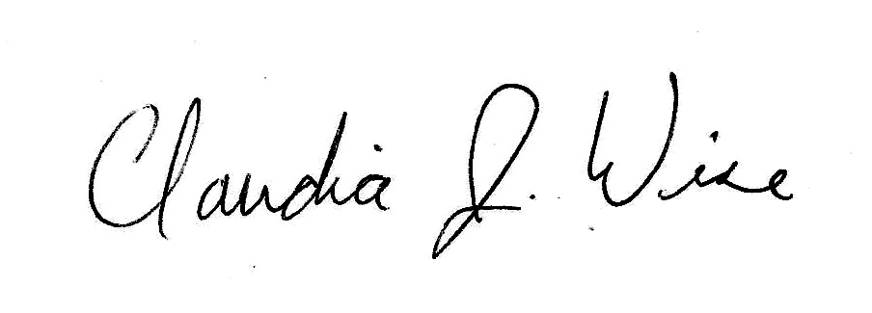
Physical Scientist, U.S. Environmental Protection Agency [RETIRED]

and

Joseph C, Greene
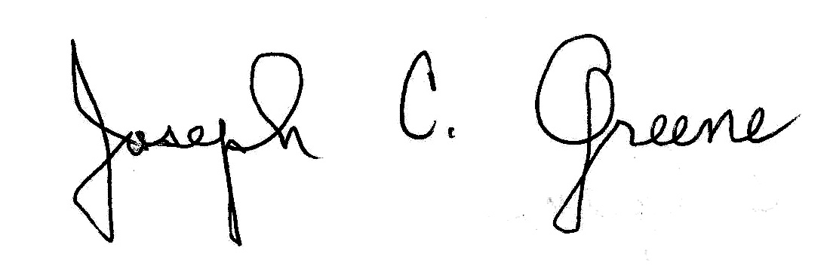
Research Biologist, U.S. Environmental Protection Agency [RETIRED]

REFERENCES

Alpers, C.N.; M.P. Hunerlach; M.C. Marvin‐DiPasquale; R.C. Antweiler; B.K. Lasorsa; J.F. DeWild; and N.P. Snyder. 2006. Geochemical data for mercury, methylmercury, and otherconstituents in sediments from Englebright Lake, California, 2002. USGS Data Series 151, 95p.
Beijer, K., A. Jernelov (1978). “Ecological aspects of mercury--selenium interactions in the marine environment.” Environ Health Perspect 25:43-5.
Curtis, J.A.; L.E. Flint; C.N. Alpers; S.A. Wright; and N.P. Snyder. 2006. Use of sediment rating curves and optical backscatter data to characterize sediment transport in the upper Yuba River Watershed, California, 200103. USGS Scientific Investigations Report 2005‐5246, 74 p.
Dietz, R. , F. Riget and E. W. Born. An assessment of selenium to mercury in Greenland marine animals. The Science of The Total Environment. Volume 245, Issues 1-3, 17 January 2000, Pages 15-24
Fleck, J.A.., Alpers, C.N., Marvin-DiPasquale, M., Hothem, R.L., Wright, S.A., Ellett, K., Beaulieu, E., Agee, J.L., Kakouros, E., Kieu, L.H., Eberl, D.D., Blum, A.E., and May, J.T., 2011, The effects of sediment and mercury mobilization in the South Yuba River and Humbug Creek Confluence Area,, Nevada County, California: Concentrations, speciation, and environmental fate—Part 1: Field characterization: U.S. Geological Survey Open-File Report, 2010-1325A, 104 p.
Harris HH, Pickering IJ, George GN. 2003. The chemical form of mercury in fish. Science 301:1203.
Humphreys, R. 2005. Mercury Losses and Recovery, During a Suction Dredge Test in the South Fork of the American River. In House Report, California Water Board.
Marvin-DiPasquale, M. , et.al,. 2009. Presented at the 19th Annual Meeting of the Northern California Regional Chapter of the Society of Environmental Potential impact of disturbance events on mercury associated with hydraulic mining sediments.
Nishigak, S. and Harada, M. 1975. Methylmercury and selenium in umbilical cords of inhabitants of the Minamata area. Nature 258, 324 - 325
Parizek et al. “The protective effect of small amounts of selenite in sublimate intoxication.” Experientia. 1967 Feb 15;23(2):142-3.
Peterson, S. A. et al, 2009, How Might Selenium Moderate the Toxic Effects of Mercury in Stream Fish of the Western U.S.?, Environmental Science and Technology., 3919–3925
Prussian, A. M., Royer, T. V., and G. W. Minshall. 1999. Impact of suction dredging on water quality, benthic habitat, and biota in the Fortymile River and Resurrection Creek, Alaska. Final Report. For the U. S. Environmental Protection Agency, Region 10, Seattle, WA. 72pp.
Ralston, N. Physiological and Environmental Importance of Mercury-Selenium Interactions. United States Environmental Protection Agency National Forum on Contaminants in Fish. September 19, 2005.
SUSUMU NISHIGAKI* & MASAZUMI HARADA. 1975. Methylmercury and selenium in umbilical cords of inhabitants of the Minamata area. Nature 258, 324 - 325
US EPA, 2010, Biological Evaluation for Small Placer Miners in Idaho National Pollutant Discharge Elimination System (NPDES) General Permit, U.S. Environmental Protection Agency, Region 10, Seattle, Washington.
Yu-Wei Chen, N. Belzile and J. Gunn. Antagonistic effect of selenium on mercury assimilation by fish populations near Sudbury metal smelters? Limnology and Oceanography. 2001;46(7):1814-1818.

